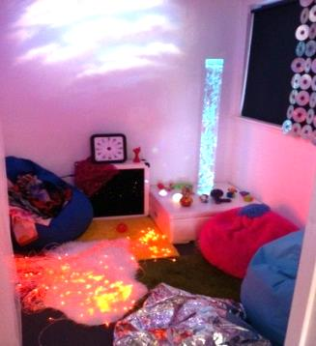Administrative Address:

The Stables, Moss of Letter

Dunecht, Aberdeenshire, AB32 7EQ

Dear Sir/Madam,

**Please take a few minutes to learn about our unique charity and our work in your area….**

[SensationALL](http://www.sensationall.org.uk/) is a charity based in Westhill, set up and run by a group of parents and professionals who live and work with people with **Multiple Support Needs (MSN).** MSN refers to many factors including physical disabilities, learning difficulties, sensory impairment, social-communication difficulties and/or medical needs. We provide specialist, subsidised play, leisure, learning and sensory activities for children and adults with MSN and their families across the North East of Scotland. We also deliver high quality education and training helping to empower families and support their needs.

We have several ongoing initiatives, as well as aspirations for the future, including:

* Family Stay & Play
* Outreach Sensory Sessions and Training Workshops
* Outdoor play equipment
* Book and Resource Library
* Parent and Professional Training Workshops
* Social Groups/Activities
* Relaxation Sessions
* Music and Movement
* Arts & Craft Sessions
* Music Therapy Groups
* Community Choir

We frequently make presentations to groups and organisations with a view to raising awareness of our work, as well as gaining support for our future plans which include; specialised bikes and outdoor equipment, a book and resource library, parent training workshops and the development of various social groups/activities. We also have soft play room resources, and resources to create a well needed safe environment for more active users, once we have been successful in acquiring more suitable premises.

SensationALL runs with the help of [volunteers](http://sensationall.org.uk/index.php/get-involved) and we greatly appreciate anyone contacting us who may be willing to give up a few hours of their time to help us in some way. Volunteers could be working directly with the families/users, manning the refreshment area, help with admin tasks, fundraising or applying for grants amongst other tasks or assisting with the extensive task of new premises project management. Volunteering may involve giving an hour of your time every now and again to a few hours regularly, every little helps and we would love to see any of your staff if they were interested in joining us.

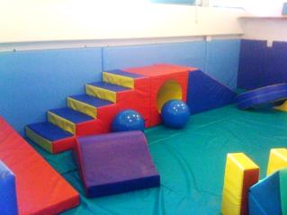If you are interested and/or would like to find out more about our work, please do not hesitate to contact us at [info@sensationall.org.uk](mailto:info@sensationall.org.uk) or call us on 01224 746699. We would love to share our story and ‘vision’ for the future!

Thank you for taking the time to consider this worthwhile cause.

**Susan Kay**

Co-founder & Chairperson

Website: [www.sensationall.org.uk](http://www.sensationall.org.uk/). Video clips: [You Tube](https://www.youtube.com/channel/UCPJBIhlKZDovyi85xZUniYA). Connect: [facebook.com/SensationAll](http://www.facebook.com/SensationAll.org.uk)